Detailed Proposal to Proposal to Increase Diversity in Tamid

Problem Section

Tamid has failed to devise a way to reach and attract a more diverse group of applicants. The majority of members and applicants are religious Jews, most of whom also actively participate in Hillel. The current lack of diversity significantly hampers the organization’s ability to meet its objectives and goals.

Recruiting students with the greatest potential to be successful as consultants and active contributors to Tamid will determine the group’s long-term success. The groups reputation and prestige in the Israeli and Jewish business communities while growing, is still relatively small. Therefore in order to grow in influence Tamid must meet and exceed the expectations of clients and investors.

Appealing to diverse students is instrumental in making Tamid more successful. As Tamid grows so will the complexity of consulting projects. Simply put, increasing the number of applicants increases the likelihood that Tamid will be able to fill available spots with the best possible people. Additionally, Tamid misses benefits derived from diverse teams. Studies from the Kellogg School of Management and Aarus University indicate “diversity triggers more careful information processing” and “is an important source of innovation” (7,8).

From a broader organizational perspective, the lack of diversity limits Tamid’s ability to expose a segment of students to Israel that are not already closely connected to the country. Increased diversity could benefit Israel. According to Karen Kisos, a former board member of a prominent Israel based non-profit, “a connection made to Israel from someone who likely would never have any ties to the country could be as [valuable], or even more valuable, then reaffirming a connection with someone who visits Israel regularly and speaks the language.” The two reasons given for this argument were the significant impact connecting non-Jewish Americans could have on the economy, both from foreign direct investment and tourism and the necessity for Israel to maintain high favorability ratings in America. The latter is important due to the substantial U.S. federal funding to Israel and U.S. support in the UN Security Council. Educating students about business, from an Israeli perspective, will positively predispose Tamid members to the country.

Tamid’s failure to attract diverse members is caused by a brand that ignores the message of inclusiveness, promotional materials that do not resonate with diverse audiences, and Tamid recruiters’, or members’, failure to sell Tamid effectively to diverse potential recruits.

Tamid Brand

The current Tamid brand is targeted to Jewish students, not to the broader student community. A brand, according to Daniel Bonevac and Casey Jones is “a definition of a particular company or product” (4). The definition is further broken down into the categorization of the product or service, as determined by the customer, and how it is differentiated from competitors. To most members Tamid’s brand would be described as a business club that is differentiated from competitor business clubs because it works with Israel. This differentiation would likely not appeal to non-Jewish students, as they probably have no desire to connect with Israel.

Tamid’s official name, Tamid Israel Investment Group Ltd, has the potential to further alienate potentially interested students. Tamid lacks an established brand with non-Jewish underclassmen and the name is likely the first interaction they have with Tamid. The name itself creates several problems. The first is the word Israel. When asked, in a focus group “describe to me what you think Tamid Israel Investment Group is,” Nikola Ralev answered “a Jewish finance society” (Appendix F). No one in the focus group disagreed with Nikola. The initial categorization of Tamid as a Jewish business club could immediately make Tamid unappealing to non-Jewish students. Another problem with the name is that Tamid is not just an investment group. As you know, it is also a consulting group and includes an educational component, speakers and networking events. This labeling misleads students that may be more interested in the non-finance aspects of Tamid.

Tamid’s logo, exhibited in appendix A, tested well in the focus group, but only because the Hebrew letters went unnoticed. After asking the group’s feedback about the presence of Hebrew on the logo, their opinions immediately changed. Ismaeel Faridi originally said he thought the logo was fine, but after being informed about the Hebrew letters said, “I wouldn’t consider joining because I would think it was just for Jewish students.”

Promotional Materials

Tamid’s promotional materials lack the quality to best attract potential recruits. Promotional materials are one of the primary mechanisms Tamid uses to attract potential recruits. The promotional materials in use include two flyers and a brochure (Appendix B, C and D). All three were tested in a focus group and received significant criticism (Appendix F).

Flyers are essential to Tamid’s ability to expand outside of the religious Jewish community, as they serve as a mechanism to reach students outside of members’ direct social circles. Two different flyers were used during the fall 2013 semester, and both failed to effectively attract diverse students. According to Manuel Garcia, a founder of designrshub.com, the most important step in designing a flyer is setting up goals. The flyers, shown in appendices B and C, likely have the goal of serving as a reminder for dates of application deadlines and information sessions, both of which are listed prominently. But, due to low brand-awareness among non-Jewish students, Tamid should also have the goal of informing readers about Tamid. Nowhere on either flyer is there any indication of what Tamid does. Therefore, these flyers are only relevant to students who are already familiar with Tamid. Without information nothing is present to entice students to inquire further about the club.

Several features of the flyers could also serve as immediate disqualifiers for non-Jewish students. Both the Tamid Israel Investment Group name and the logo were identified during a focus group as things that should be changed. The name and the Hebrew letters on the logo lead to the immediate association with Judaism and the perception that Tamid was a club exclusively for Jews. The location of the application workshop in Hillel, mentioned in Appendix C, was also identified as something that should be changed. Similarly this was also perceived as an indicator that this is a religious group.

The brochure, shown in appendix D, received more positive feedback from the focus group, yet was still criticized for having too much text and too few pictures. Professors at the University of Nebraska mentioned several rules for brochure design including, “include five or fewer key points” and “use pictures, charts, and drawings rather than words when possible” (2). This brochure violates both of these principles as it has seven points made and contains only one picture that adds no value.

Tamid Recruiters

Tamid is failing to best utilize its own members as recruiters for the club. In the survey you helped me administer to the group, a significant percentage cited a conversation with a Tamid member as the determining factor in their decision to apply. But, of those members almost all mentioned yourself, Ira or Joseph, as the person they spoke to. Word-of-mouth marketing has proven extremely successful in the past. In an interview Duy Tran revealed he initially dismissed Tamid after seeing the table at the First Look Fair, but a conversation with Joseph convinced him to apply. The main problem is that most members either fail to work to recruit new members or are ineffective in their efforts. Tamid’s inability to maximize potential of current members as recruiters will diminish the likelihood the organization can branch out and attract diverse students.

Problem Summary

Increasing diversity in Tamid is a difficult task but its failure will seriously hurt the organization. A lack of diversity recruitment prevents Tamid from selecting the best talent and diminishes the possible organizational benefits deriving from more diverse teams. It also diminishes Tamid’s goal of promoting Israel and supporting the Israeli economy. While the consequences of failure are real, the problem is solvable. Three main problems exist: the brand, promotional materials, and Tamid recruiters. Once these three issues are dealt with Tamid should see an increase in diverse applicants next Fall.

Solution

Tamid Brand

Tamid must find a way to target a new audience while not alienating its current base, the religious Jewish community. For religious Jews the connection to Israel is very important, but for non-religious Jews it either doesn’t matter or, as described in the problem section, could lead to a belief that the club is exclusively for Jews. Therefore in order for Tamid to appeal to non-religious Jews it must mitigate the aspects of the brand that could potentially mislead and focus the brand on the aspects of Tamid that appeal to a broader audience.

Tamid Brand Name

The name Tamid Israel Investment Group is the first thing that must change. According to Professor Kim Robertson, a professor at Trinity College, a brand name must be “simple, meaningful and distinctive” (11). There are many possible names that could fit this description such as Tamid Investment and Consulting Group, Tamid Advisors, Tamid & Co. (the industry standard for consulting groups), or just Tamid. Abandoning Tamid was not considered as this name has already built a brand in the broader Jewish community. In a survey of 20 students each was asked to select their top choice of the options listed above and the current name after being read this description:

“Tamid is an on-campus investment and consulting group with goals of student professional development and of educating students about business opportunities in Israel. Tamid consults for and invests in companies primarily based in Israel. Tamid is not a political or religious group. Tamid is looking to attract a diverse group of students. Which brand name do you believe best matches the description and would be most appealing to you?”

The results are shown below:

Figure 1

The results indicate a strong preference toward Tamid Investment and Consulting Group. This name might not be flashy, but it describes enough of what Tamid does to get peoples’ attention and emphasizes a main point in Tamid’s rebranding strategy, which is the opportunity to gain real-world experience. It also does not alienate people by giving a false perception that Tamid is a group just for Jewish students.

Brand Positioning

Tamid’s brand must also be positioned in a way that provides a deeper connection to diverse students. A brand should not just answer, “what [an organization does],” but also “why they do it” (6).” With the assumption that diverse students have no desire to promote Israel, other factors that could serve to differentiate Tamid must be discovered and then conveyed to this target group. Israel must also be explained in a business and non-religious context.

Tamid’s brand must emphasize what students are seeking in a club. Students at the University of Maryland have many choices in how to spend their time outside of the classroom. Tamid must standout on differentiating factors for non-religious Jews. According to Jeanette Snider, an undergraduate advisor in the Smith School of Business, students in the business school look for “something that will look good on a resume and assist in getting a job”. Survey results confirm this sentiment with a majority of students listing something that looks good on a resume as the most important factor for joining a business-related club.

Tamid must position itself in a way that meets the needs of the target market and encourages selection over other available options to students. According to Marjorie Bonavia, a consumer analysis professor in the R.H. Smith School of Business, a “consumer can only remember 5 things about a brand.” Therefore the two additional attributes that should be emphasized in addition to Tamid being a business club, an investment group, and a consulting group are that it looks good on a resume and will assist in finding a job. The combination of real world experience and networking opportunities is mostly unmatched by any club at the University. This is what Tamid must emphasize to differentiate the club.

Tamid must also mitigate potential misconceptions about Tamid’s association with Israel. My recommendation would be to avoid the word Israel on all materials that could potentially serve as the first point of contact with potential recruits. As will be explained in the personal selling section, Tamid’s members should explain the organization’s connection with Israel.

Rebranding must occur, but it in a way that maintains Tamid’s recruiting effectiveness and credibility with religious Jews. The solution to this dilemma is twofold. Tamid should use different marketing strategies for religious Jews and nonreligious Jews. This means continuing the strategies currently in place that have worked in the religious community. Marketing to this group of students can largely be accomplished through word of mouth marketing and promotions in Hillel. However, in order to maintain credibility everything about the new brand must remain truthful. There is difference between hiding Tamid’s connection with Israel and explaining the organization in a way that is appealing to non-religious Jews. This point will be further elaborated on in the personal selling section.

Personal Selling

Training and motivating Tamid members to recruit is the most cost-efficient and effective way for Tamid to increase diverse applicants. The majority of current Tamid members and all non-Jewish members cited conversations with Tamid members as a major factor in their decision to apply. The reasoning for this is that what Tamid offers is unique. Tamid has real money to invest in stocks and world-class consulting clients like Wix and Woodbridge International. It is an organization that is growing rapidly and has chapters at many Ivy League schools. This should appeal to everyone, but a lack of awareness and false perceptions about the clubs association with religion undermine this. Personal selling can combat both of these problems.

Align Business Objectives and Learning Needs

Realistic goals for recruitment are essential in ensuring sustainability for any recommendations given in this proposal. World-renowned sales expert Mike Schultz describes four questions that must be asked before developing a sales plan:

- What is the business outcome that we believe we can achieve?
- What does our sales team need to do to achieve that outcome?
- What is the gap between where they are now and where they need to be?
- What kind of initiative will it take to get our team from Point A to Point B, and keep them there?

The answers to these four questions provide a path Tamid can take to go from a business objective to determining what needs to be taught. An example of a business outcome Tamid can strive for is 76 applications and at least 20 non-Jewish applicants gained through personal recruitment. To accomplish this every Tamid member must recruit one student and give one classroom pitch. Board members must recruit two members, one of whom must not be Jewish, and give two classroom pitches (Appendix G). A classroom pitch is asking permission of a professor to give a short pitch about an organization during class-time. As mentioned earlier, while conversations with Tamid members were cited as a major factor in decisions to apply, only three Tamid members were named, one of whom, Ira, is no longer with Tamid. Therefore, Tamid currently only has two members that have shown the capability to meet this objective. In order to accomplish this goal Tamid needs a motivation scheme and a sales training program to ensure Tamid members can meet their objectives.

Motivation Scheme

Tamid must use incentives to motivate members to recruit. Motivation “can be broken down into extrinsic and intrinsic motivation” (10). Extrinsic incentives could include monetary benefits, leadership positions, the fellowship, or priority selection of consulting projects. However, it is my belief that all of these methods have costs that outweigh their potential benefits.

Providing a financial reward to the most successful recruiters would not be an efficient way to motivate members. Tamid is on a tight budget. So in order to make a decision to give money to the best recruiters, an argument must be made that this is the best possible use of this money. This is not the case. Chances are that the amount Tamid could offer would not appeal enough to entice members to change their behavior. Instead, the same people who are always active would continue to work hard, but under this scheme we would have to pay them. This relates to the expectancy theory which argues that “the strength of our tendency to act a certain way depends on the strength of our expectation of a given outcome” (10). In addition to the cash prize being small, it would go, at most, to only the top three or four recruiters. The expectation of achieving the reward in this scenario is very low. Which means, according to this theory, motivation will also be low.

Tamid should also not use rewards relating to leadership positions, the fellowship, or priority selection of projects. Tamid leadership should base these types of decisions on what they feel is best for the organization. Being a strong recruiter does not directly translate into being a strong project manager or the best candidate for a fellowship. Directly tying recruiting performance to extrinsic rewards could also anger members who may be more deserving when the semester is done. Alfie Kohn, an author of several management books, argues “when people do not get the rewards they were hoping for, they feel punished. And the more desirable the reward, the more demoralizing it is to miss out” (5). Tamid leadership must make it clear that they will notice strong performances in recruiting and this will play a role in leadership positions, the fellowship, and priority selection of projects. But making this the deciding factor puts Tamid at a risk of having the wrong people in sought after positions and demoralizing those who actually deserve it.

The most effective way to motivate recruits is through empowering members. Pete Carroll, the head coach of the Seattle Seahawks, believes that you “create a motivational environment by empowering people, and setting high goals while maintaining standards” (Langa). To empower members Tamid should allow individual project teams to develop their own goals. To ensure the goals are challenging enough a bare minimum level, such as the objective stated in the previous section, will be set at a project manager meeting prior to the individual team meetings. Emphasizing the necessity of recruiting diverse students must be a top priority at this project manager meeting. Each team will set two goals. The first is the number of referrals they plan on obtaining. To track this on each application there will be a question asking applicants if they were referred by any Tamid member and under that a dropdown menu with all members’ names. The second goal is the number of classroom presentations each group is responsible for. Project managers will be responsible for reporting this.

To ensure this program is taken seriously by members everyone must be held accountable. Project managers will be responsible for ensuring their members stay on target and Tamid leadership is responsible for getting weekly progress updates from project managers. There should be no negative repercussions for failure, but if a team is unsuccessful a meeting with Tamid leadership must take place to figure out why.

The concept is simple and it is one that has proven very successful in my own endeavors as a project manager. We make all of our decisions about work done outside of meetings as a group. That way there is no excuse for anyone not following through. As a team we have not missed any deadlines and when a member misses an individual deadline a one-on-one conversation occurs after our next group meeting to discuss why that was the case.

Sales Training Program

The sales training program is the first step in preparing members to become better recruiters. The training phase must include three topics: product fluency, the elevator pitch and diversity recruitment training. This training program will be a two-hour event that occurs during the first meeting of the Fall semester.

Tamid members must know about all aspects of Tamid in order to maximize their ability to sell the organization. A possible reason that only upper-level management of Tamid has been successful recruiting is that they are the only people with enough knowledge to feel confident pitching the organization. To increase all members’ knowledge about Tamid fund and project managers will submit a memo of what their team’s worked on the previous semester for everyone to read prior to the sales training event. A sample memo for a consulting project is shown below.
Figure 2
MEMORANDUM
September 2, 2014
TO: Tamid Members

FROM: Keshet Advisors Project Managers

SUBJ: 2014 Spring Semester Report

Company Description

Keshet Advisors is an investment advisory and consulting firm, with a wide range of professional services linked to private equity. Their services include business consulting for start-up companies and investment firms, mergers and acquisitions services, and fundraising.

Project Description

Over the course of the Spring semester the Keshet Consulting team primarily worked on three projects. The first two were conducting basic research on startup companies in Israel and then matching up those companies with potential investors abroad. We also sourced potential investors for Viola capital, a large client of Keshet Advisors.

The first project was relatively simple research on companies our Keshet Advisors contact selected for us. We researched approximately 450 startups. We primarily gathered information from company websites, but also used sources such as Hoovers, CrunchBase, LinkedIn and articles found online. We submitted an excel document with a two to three sentence description of each company.

Additionally, we also attempted to match these companies with potential investors. Our company contact gave us an investor criteria sheet that outlines what large investment firms look for in potential investments. Using this information we attempted to find matches. This information was again inputted into an excel sheet.

Sourcing potential investors for Viola Capital was our final project. We put together a 100-person list of wealthy individuals with contact information. We also drafted email templates and scripts for phone calls specific for each potential investor that Keshet could use when reaching out to these individuals.

Time in the training session must be spent ensuring that members are knowledgeable about Tamid. While it would be ideal for members to read all of the memos prior to the session, in all likelihood this will not be the case. During the first 30 minutes of the event project managers will give short two-minute presentations about their team’s work and then field questions from Tamid members. Event organizers will also print copies of the memos to distribute to Tamid members during this stage of the session.

Elevator Pitch

The elevator pitch, a short speech that discusses key elements about the club, is the most important factor in attracting diverse students. The lack of awareness outside the Jewish community will mean that in a short time span recruiters must entice students to want to learn more. The elevator pitch must reflect the brand very closely and explain “what the business does, who it targets, and why it's unique. It must also “mention recognizable clients and projects and stress key words that illustrat the firm's qualities” (14). An example elevator pitch is given below:

Tamid Investment and Consulting is a business club with an investment and consulting arm. The fund, a team of around ten students, has $10,000 to invest in the stock market. On the consulting side teams of four to five students complete projects for some of the hottest startup companies in the world like Wix and Interlude. No other club at the University invests real money and our list of consulting clients is far superior to any other club on campus. Our mission is to give students real world experience and give them the best chance to succeed in their professional careers.

Elevator pitches should be adapted to the audience. In the religious Jewish community Israel is a determinant attribute and therefore should be in the pitch. Business majors want assistance in finding a job, while engineers want to learn about business and how to solve problems. Adapting to the situation and audience is essential to delivering the most effective pitch possible. Developing this ability takes practice.

The next hour of the training event will be spent practicing elevator pitches. There are many methods for practicing, but the easiest and most cost-effective is role-playing. “In role playing the trainee acts out an event such as the sale of a good or service to a hypothetical buyer” (15). During the event Tamid members will first hear several elevator pitches from Tamid leadership corresponding to a fake person’s major and background. If the target audience was described as a business major then the elevator pitch above would be suitable. After Tamid leadership demonstrates the activity, Tamid members will break into small teams and each team will respond to similar scenarios. Throughout this activity Tamid leadership will walk around to ensure the activity is being taken seriously. To culminate the activity the best person from each group will compete in an elevator pitch competition.

Diversity Training

This final part of the training session will provide Tamid members with the necessary encouragement and information to pitch Tamid to a non-Jewish audience. During this session Tamid leadership will explain the new Tamid brand and emphasize the importance of recruiting non-Jewish members. I can give a presentation making the argument that Tamid cannot meet its organizational objectives unless it recruits more diverse students. This presentation will strive to gain organizational commitment for the cause. In addition to explaining why, the presentation will also provide answers Tamid members can give when students ask why Tamid is associated with Israel.

Israel Connection

Israel must be conveyed as the entrepreneurship hub of the world, or the Start-Up Nation as branded by Dan Senor and Saul Singer in the New York Times best seller. To non-Jews the most likely association with Israel is Judaism. Tamid members must convince non-Jews of a significant business reason for why Tamid chooses to work with Israel. The most effective way of doing that is through facts. Israel has the highest “density of start-ups in the world” and more companies on the Nasdaq than all of Europe (12). Also almost half of the world’s top technology companies have bought start-ups or opened research and development centers in Israel” and in 2006 Warren Buffett “broke his decades-long record of not buying any foreign companies by buying an Israeli company for $4.5 billion” (12).” There are many other statistics available that serve the same purpose of explaining why Tamid works solely with Israel in a way that would appeal to non-religious Jews. Tamid members must memorize these facts and be able to recite them if this question arises. Also according to Michael Poerksen, a human resource director at Ernst and Young, that “in a global economy international connections are becoming increasingly important.” Emphasizing both of these points should be enough to turn Tamid’s connection with Israel from something potentially negative to a positive.

Promotional Materials

Tamid’s promotional materials should be altered to reflect the changes to the Tamid brand and address concerns brought up by the focus group. The common changes made to both the flyers and brochure include removing all reference to Israel, simplifying the message of what Tamid does and replacing the Tamid logo.

Logo

The Tamid logo was left largely unchanged. It originally tested well in the focus group. Tamid is marketing itself as business club and therefore the only real requirement is that it looks professional. The only difference between the two logos is the new one does not have Hebrew letters in the letter D. This aligns with the strategy of portraying Tamid as a business club and letting members explain the organization’s connection with Israel.

Before After
Figure 3 Figure 4

Flyer

Tamid flyers must align with the new brand, while also addressing problems brought that the focus group identified. The Tamid flyers used during the fall semester did not appeal to students who were not already familiar with Tamid. The major changes from the previous flyers include the new name, the new logo, a short description of Tamid and an emphasis on the fund and consulting, the two most appealing aspects of the club.

The general consensus of two focus groups is that the new flyer better serves the purpose of appealing to all students. Two focus groups, one comprised of Tamid members and another of non-members, were each given the three flyers and asked to choose their favorite (Appendix L). Everyone voted for the new flyer. The only criticism given was the flyer had too much text. However, all of the text is necessary to persuade someone who has never heard of Tamid to inquire further. This flyer answers what is Tamid and what does Tamid do. A flyer’s purpose is to attract interest and with the answers to these questions students can make an accurate assessment of whether Tamid is right for them.

Old Flyers

Figure 5
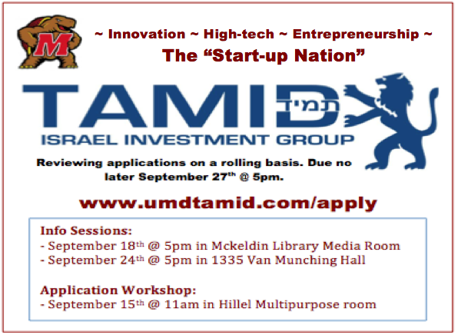

Figure 6

New Flyer

Figure 7

Tamid Brochure

Similarly, changes with the brochure were necessary to emphasize the five attributes of the new Tamid brand and address the concern that there was too much text. The major changes include the logo, the deletion of references to the education and fellowship phases, and the inclusion of an upcoming events section.

Opinions about the new brochure were mixed, but overall the two focus groups favored the new brochure over the old. The focus group with the non-Tamid members unanimously preferred the new brochure. Nikola Ralev said that after reading the new flyer Tamid is “something he would consider joining.” The focus group appreciated the simplicity of it. On the original flyer they thought there were too many points trying to be put across.

However, omitting information was also a point of contention for the focus group with Tamid members. The major fault two members had with the new brochure was that they thought the fellowship should be mentioned. Rebecca Grossman described the fellowship as one of the primary reasons she joined Tamid. The reason the fellowship was not included on the flyer was the fellowship’s connection with Israel. This also could bring up an association with Birthright, which is commonly known as being exclusively for Jews.

Old

Figure 8
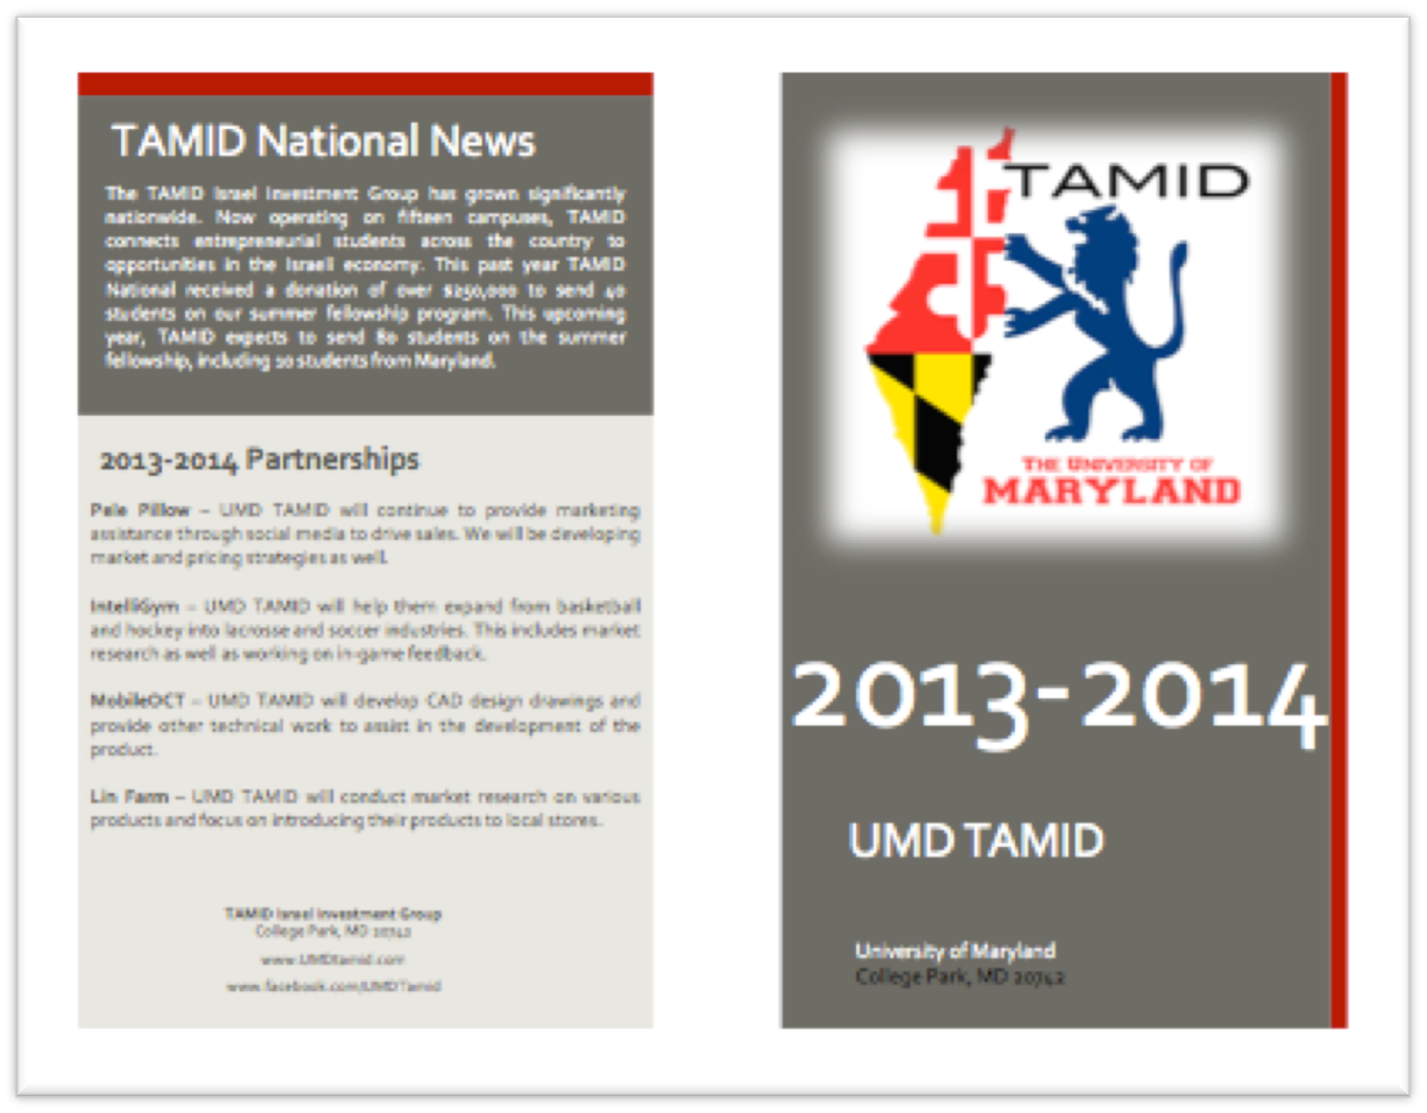
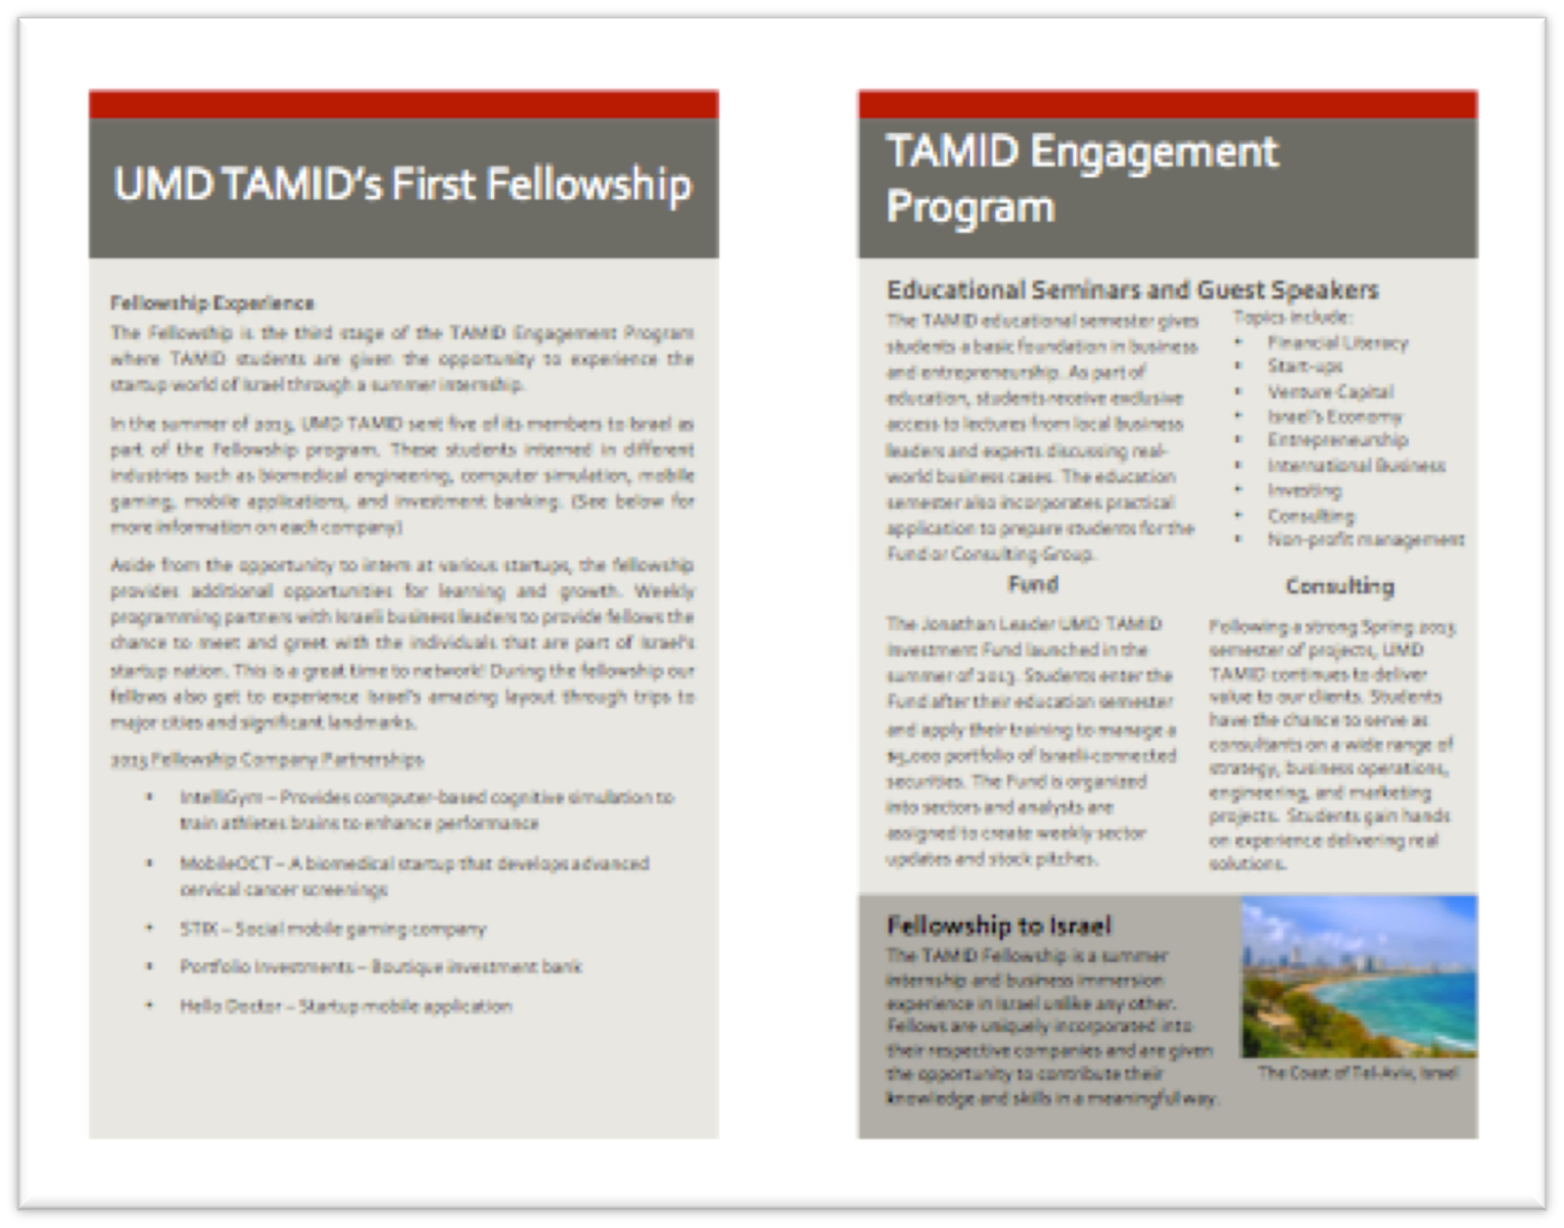

New

Figure 9

Personnel

My experience and qualifications make me the best person to spearhead the implementation of my recommendations. Each of the three categories: the brand - promotional materials, and recruitment training - require different people to assist in their implementation. However, my previous experience working in these areas and my research throughout this semester put me in a position to take a leadership role.

Tamid’s top leadership must agree to the changes regarding the brand. Changing the brand does not require any additional work, but organizational commitment is vital to its success. This starts with you and Joseph Tuchman getting behind the concept and ensuring that all marketing keeps the new brand in mind.

The recruitment event requires the assistance of two to three Tamid members to help in organizing and running the event. Ideal choices for these roles are next semester’s director of recruitment and director of marketing. In the process of planning this event prior to Tamid’s first meeting they can be caught up on the new Tamid brand and recruitment strategies. These members can also be in charge of printing the memos and agendas for each member.

A board meeting must also take place to discuss the recruitment plan. This meeting should take place before the start of the fall semester meaning someone should be in charge of organizing the meeting’s location and sending out e-mails.

Finally, Tamid members must print out the promotional materials and place them in ideal locations around campus. However, this is not additional work as this is currently done for the existing promotional materials.

Budget

The only additional costs come from printing out memos and agendas for each member at the sales event. The University of Maryland Library charges $0.10 a page and so for eight project memos and an agenda per person this comes to $41.80.

All other costs replace expenditures that already take place. Tamid must print the same amount of promotional materials and the new design has no additional cost.

Old inventory does not need to be thrown out. Tamid can still use these materials in Hillel. The only difference is that Tamid must print new flyers earlier than expected.

Budget Spreadsheet

Figure 10
Members | Projects | Memos | Agenda | Paper | Cost per paper | Total Cost
47 | 8 | 376 | 42 | 418.00 | $0.10 | $41.80
Works Consulted

Texts:

- Barta, Thomas, et al. “Is there a payoff from top-team diversity?” McKinsey Insights & Publications (2012). Web. 9 March 2014.

- Garcia, Manuel. “10 Working Tips in Creating Effective Flyer Designs.” Designrshub.com. N.D. Web. 27 March 2014.

- "Insiders Guide to College Admissions." Reform Judaism Magazine Fall 2010. Web.

- Jones, Casey and Daniel Bonevac. “An Evolved Definition of the Term Brand: Why Branding Has A Branding Problem.” Journal of Brand Strategy 2.2 (2013): 112-120. Business Source Complete. Web. 9 March 2014.

- Koln, Alfie. “For Best Results, Forget the Bonus.” New York Times (1993). Web. 4 April 2014.

- Lamb, Charles, et al. “MKTG 7”. South-Western (2013). Text. 9 March 2014.

- Phillips Katherine, et al. “Better Decisions Through Diversity.” Kellogg Insight. (2013). Web. 9 March 2014.

- Parrotta, Pierpaolo, et al. “The Nexus between Labor Diversity and Firm’s Innovation.” IZA DP No. 6972. (2012). Web. 9 March 2014.

- Pennisi, Lisa, et al. “How to Create an Effective Brochure.” NebGuide. (2010). Web. 9 March 2014.

- Robbins, Stephen and Timothy Judge. “Organizational Behavior.” Pearson (2013). Text. 9 March 2014.

- Robertson, Kim. “Strategically Desirable Brand Name Characteristics.” Journal of Consumer Marketing (2007). Web. 4 April 2014.

- Senor, Dan and Saul Singer. “Start-Up Nation.” Twelve (2009). Text. 9 March 2014.

- Schultz, Mike. “7 Keys For Sales Training With Maximum Impact. T+D (2013). Business Source Complete. Complete Web. 30 Apr. 2014.

- Maltby, Emily. “Three minutes to win a million” Wall Street Journal (2010). Web. 9 March 2014.

- The Management of Sales Training and Development. Text. Web. 9 March 2014.

Experts

Koffler, Caleb. Interview. 1 February 2014

Kisos, Karen. Interview. 3 February 2014

Tran, Duy. Interview. 29 January 2014.

Snider, Jeanette. Interview. April 15 2014.

Bonaiva, Marjorie. Lecture. April 2014.

Langa Gosia. Lecture. November 2013.

Ralev, Nikola. Focus Group. 5 February 2014.

Liu, Chelsea. Focus Group. 5 February 2014.

Faridi, Ismaeel. Focus Group. 5 February 2014.

Moore, Catherine. Focus Group. 5 February 2014.

Ralev, Nikola. Focus Group. 24 April 2014.

Liu, Chelsea. Focus Group. 24 April 2014.

Faridi, Ismaeel. Focus Group. 24 April 2014.

Moore, Catherine. Focus Group. 24 April 2014.

Grossman, Rebecca. Focus Group. 25 April 2014.

Gold, Shmul. Focus Group. 25 April 2014.

Leeb. Marc. Focus Group. 25 2014.

Appendix

Exhibit A

Appendix B

Appendix C

Appendix D

Appendix E

Survey
Number of Respondents: 35
Questions asked:
- What religions do you identify with?
- How many times have been to Israel?
- At what level do you speak Hebrew?
- Are you an active participant in Hillel?
- What was the main factor in your decision to join Tamid?
- How did you first hear about Tamid?

Appendix F

Focus Group
Date: February 5, 2014
Number of Participants: 4
Moderator: Daniel Spencer
Description: Participants were not familiar with Tamid before the focus group. Each question was asked and then left open for discussion. On occasion the moderator would probe for additional information. Before starting participants were told “Tamid Israel Investment Group is an on-campus club”.
Questions asked:
- Just from hearing the name what do you think the club is?
- What are your opinions of the Tamid logo? (Appendix A)
- How would you improve the logo to appeal to a more diverse audience? (Appendix A)
- What are your opinions of the Tamid flyer (Appendix B)?
- How would you improve the flyer to appeal to a more diverse audience? (Appendix B)
- What are your opinions of the Tamid flyer (Appendix C)?
- How would you improve the flyer to appeal to a more diverse audience? (Appendix C)
- What are your opinions of the Tamid brochure (Appendix D)?
- How would you improve the brochure to appeal to a more diverse audience? (Appendix D)
Appendix G

Appendix H

Focus Group
Date: April 25, 2014
Number of Participants: 4
Moderator: Daniel Spencer
Description: Participants were vaguely familiar with Tamid before the focus group having participated in a previous focus group. Each question was asked and then left open for discussion. On occasion the moderator would probe for additional information. Before starting participants were told “Tamid Israel Investment Group is an on-campus club”.
Questions asked:
- Which flyer is your favorite?
- Why is ___ your favorite flyer?
- How would you improve the new flyer?
- Which brochure is your favorite?
- Why is ___ your favorite brochure?
- How would you improve the new brochure?
Appendix I

Focus Group
Date: April 24, 2014
Number of Participants: 3
Moderator: Daniel Spencer
Description: Participants are Tamid members. Each question was asked and then left open for discussion. On occasion the moderator would probe for additional information. Before starting participants were told “Tamid Israel Investment Group is an on-campus club”.
Questions asked:
- Which flyer is your favorite?
- Why is ___ your favorite flyer?
- How would you improve the new flyer?
- Which brochure is your favorite?
- Why is ___ your favorite brochure?
- How would you improve the new brochure?

